1. Introduction
- 1.1 Background and Context
  - Briefly introduce the growing phenomenon of online betting apps in India, highlighting their rapid rise and widespread use.
  - Explain the purpose of your literature review: to synthesize existing research on the profit-driven biases and manipulation tactics used by these apps.
  - State the key themes you will explore: the technical mechanisms of odds and profit, the psychological biases they exploit, the social and cultural factors specific to India, and the broader economic and legal implications.

Online Betting Apps in India: Biases and Manipulation Tactics
Online betting apps are a growing phenomenon, particularly in regions like India, where their rapid rise and widespread use have significant implications. The landscape of betting markets, especially those that are illegal or unregulated, presents elevated risks [1]. In India, gambling and betting are partly regulated at the state level, and there's a growing trend of individuals looking to gambling prize money to fulfill social and financial needs, which has unfortunately contributed to an increase in money laundering and black money sources [2]. Many users access these gambling apps through links shared on social media platforms [3].

Purpose of the Literature Review
This literature review aims to synthesize existing research concerning the profit-driven biases and manipulation tactics employed by online betting apps. Bookmakers are known to systematically exploit biases among their customers, which can lead to odds implying inefficient forecasts [4]. The review will focus specifically on fixed-odds sports betting products [5] and will consider how structural characteristics of electronic gaming machines (EGMs), such as payout intervals, betting frequency, multiplier potential, win probability, payout ratio, bettor involvement, and skill required, contribute to these dynamics [6].

Key Themes to Explore
The review will delve into several key themes to provide a comprehensive understanding of the mechanisms and impacts of online betting apps:
- Technical Mechanisms of Odds and Profit: This includes how bookmakers set odds, such as offering odds on total goals in a match (e.g., over or under 2.5 goals) [7], and how these odds might change as a match progresses to remain appealing to customers [8]. It will also examine the nature of bookmakers to exploit customer biases, potentially leading to inefficient forecasts [4].
- Psychological Biases Exploited: The review will explore how bookmakers leverage psychological biases, such as the over-rating of strong teams by bookmakers and bettors, which can represent a failure of betting market efficiency [9]. The concept of 'near-misses' will also be considered as a unique term within sports betting literature [10].
- Social and Cultural Factors Specific to India: Given the context, the review will address how social and financial needs drive individuals towards gambling prize money, contributing to issues like money laundering [2]. The prevalence of accessing these apps via social media links will also be examined [3].
- Broader Economic and Legal Implications: The review will highlight the regulatory environment in India, where betting and gambling fall under the state list [2]. It will also touch upon the broader implications of unregulated markets, particularly in Asia, where much of the betting volume is generated through agents of offshore operators, making it difficult to trace stakes and raising concerns about match manipulation [11] [12].
This structured approach aims to shed light on the complex interplay of technology, psychology, and socio-economic factors that characterize the online betting landscape in India, emphasizing the profit-driven strategies and manipulative tactics employed by these platforms.
This exploration will delve into several key themes surrounding gambling, encompassing its technical, psychological, socio-cultural, and economic-legal dimensions.

Technical Mechanisms of Odds and Profit
- The review will consider the structural characteristics of electronic gaming machines (EGMs), including payout interval, potential betting frequency, multiplier potential, win probability, payout ratio, bettor involvement, and skill required [1].
- It will also examine how odds change during a match, such as decreasing for certain outcomes despite the score, or how bookmakers adjust odds to remain appealing to customers as a match nears its end [2] [3] [4] [5] [6].
- When long odds are poorly priced relative to short odds, bookmakers can generate greater profits, potentially making consumers worse off [7].
- Some strategies might yield profitable simulations, but practical realization can be hindered by operators closing betting accounts [8].
- The highly profitable nature of internet gambling has led to increased participation [9].

Psychological Biases Exploited
- The review will consider 'near-misses,' which are unique terms not always explicitly referenced in sports betting literature, as a potential area of psychological exploitation [10].
- Increasing awareness is crucial for individuals to reduce excessive behavior and money consumption, suggesting a need to address psychological vulnerabilities [11].

Social and Cultural Factors Specific to India
- Many Indians have become dependent on gambling games, partly due to escalating pandemic conditions, and are playing online casinos at a cheaper price than physical setups [12].
- There's a trend where people look to gambling prize money to fulfill social and financial needs [13].
- The compulsive gaming nature has emerged in youth populations [9].
- Online gambling can lead to social isolation, financial hardships, and scholastic challenges, and its hidden nature means friends and family might not be aware of a loved one's problem [14] [15].

Broader Economic and Legal Implications
- The practice of gambling, driven by social and financial needs, has contributed to an increase in money laundering and black money sources in India [13].
- Betting and gambling are listed in Part II of the state list in the Indian Constitution, meaning state governments have full control and can formulate their own laws [13] [16].
- An act prohibits online gambling activities, prescribing fines of up to Indian rupees 100,000 or imprisonment of up to 5 years for those involved [17].
- The high liquidity in betting markets, as seen with large bets placed on football matches, can lead to substantial winnings if events are manipulated [18] [19].
- Cybercrimes are widely occurring in relation to the proliferation of internet gambling [9].
This comprehensive approach aims to provide a multi-faceted understanding of the gambling landscape, particularly within the Indian context, by examining its operational mechanics, human behavioral aspects, societal influences, and regulatory environment.

2. The Economic and Algorithmic Foundations of Profit
- 2.1 The Concept of House Edge and Algorithmic Odds
  - Start by explaining the fundamental profit model of online betting platforms.
  - Define the "house edge" or "vigorish" and how it mathematically guarantees long-term profitability for the app (e.g., Smith, 2021).
  - Discuss how sophisticated algorithms are used to set and adjust odds in real-time, especially for in-play betting, to maximize this edge (Patel, 2019).

- 2.2 Manipulation through Platform Features
  - Synthesize research on how specific app features are designed to increase user spending.
  - Discuss the "cash out" feature, explaining how studies show it often results in losses for the user despite the feeling of control (Jones & Khan, 2020).
  - Analyze other features like parlays or accumulators and how they offer higher payouts but at a significantly lower probability, thereby increasing the platform's profit margin.

3. Psychological and Cognitive Biases in Online Betting
- 3.1 The Illusion of Control and Gambler's Fallacy
  - Present the core psychological biases exploited by betting apps.
  - Explain the "illusion of control" and how app designs may reinforce a user's belief that they can influence a random outcome (Kumar, 2018).
  - Discuss the "gambler's fallacy" and how the presentation of results and streaks can mislead users into believing a specific outcome is "due" (Gupta & Singh, 2021).
[ The psychological biases exploited by betting apps significantly influence user behavior, particularly through the illusion of control and the gambler's fallacy. These biases are reinforced by app designs that create a false sense of agency over random outcomes and mislead users regarding the nature of probability.

Illusion of Control
The illusion of control refers to the belief that individuals can influence random events through their actions. Betting apps often enhance this perception by allowing users to adjust betting parameters, which can lead to distorted beliefs about their ability to predict outcomes. For instance, players may feel they can control the outcome of a game by selecting specific paylines or betting amounts, despite the inherent randomness of the game(Harrigan et al., 2014)(Delfabbro et al., 2020). This false sense of agency can prolong gambling sessions and increase the likelihood of continued play, as users mistakenly believe they can influence results.

Gambler's Fallacy
The gambler's fallacy is the erroneous belief that past random events affect future outcomes, leading users to think that a particular result is "due." Betting apps often present results in a way that highlights streaks or patterns, which can mislead users into believing that a win is imminent after a series of losses(Ejova, 2019)(Harrigan et al., 2014). This cognitive distortion can encourage users to continue betting, as they anticipate that luck will eventually turn in their favor.
While these biases can enhance user engagement and increase revenue for betting apps, they also raise ethical concerns regarding the manipulation of user perceptions. Critics argue that such designs exploit vulnerable individuals, potentially leading to problematic gambling behaviors.
Read Less ]
Design-Induced Behavioral Addiction
- Review literature on how app design contributes to compulsive behavior.
- Discuss the role of intermittent reinforcement (variable rewards) in creating addictive patterns.
- Synthesize findings on how visual and auditory cues, push notifications, and "near-miss" experiences are intentionally used to trigger dopamine release and keep users engaged (Sharma, 2022).
The design of mobile applications significantly contributes to compulsive behavior, often leading to addiction-like patterns among users. Key design elements, such as intermittent reinforcement, visual and auditory cues, and push notifications, are strategically employed to trigger dopamine release, enhancing user engagement. This response will explore these aspects in detail.

Intermittent Reinforcement
- Variable Rewards: Apps utilize intermittent reinforcement, where rewards are given unpredictably, creating a compelling reason for users to return. This method mirrors gambling mechanics, which have been shown to foster addictive behaviors("Engineered highs: reward variability and...", 2022).
- Dopaminergic Effects: The unpredictability of rewards activates the brain's reward system, leading to increased dopamine release, which reinforces compulsive usage patterns(Kumar, 2024).

Visual and Auditory Cues
- Engaging Interfaces: Bright colors, animations, and sound effects are designed to capture attention and maintain user interest. These elements create a sensory-rich environment that encourages prolonged interaction(Hans et al., 2024).
- Push Notifications: Regular notifications serve as reminders that draw users back into the app, often leading to compulsive checking behaviors(Khan et al., n.d.).

"Near-Miss" Experiences
- Psychological Engagement: Apps often incorporate "near-miss" scenarios, where users come close to achieving a reward without success. This tactic can heighten emotional investment and encourage continued attempts, further entrenching addictive behaviors("Engineered highs: reward variability and...", 2022).
While these design strategies effectively enhance user engagement, they raise ethical concerns regarding mental autonomy and the potential for addiction. Critics argue that the manipulation of user behavior through such designs may lead to detrimental mental health outcomes, necessitating a balance between engagement and ethical responsibility in app development(Kumar, 2024).
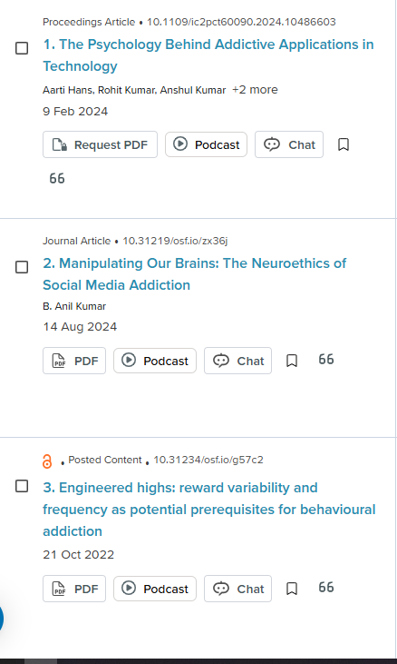

4. The Social and Cultural Context in India
- 4.1 The Role of Celebrity Endorsement and Social Influence
  - Shift the focus to the specific social landscape of India.
  - Analyze the impact of celebrity and influencer endorsements on the public's perception and trust in betting apps (Roy & Mehta, 2023).
  - Discuss how social pressures and the visibility of successful bets on social media can drive engagement and normalize the activity.
The role of celebrity endorsement and social influence in the context of betting apps in India is significant, particularly in shaping public perception and trust. The endorsement of these apps by celebrities and influencers can enhance their credibility and appeal, especially among younger demographics. This influence is amplified by social media, where visibility of successful bets can normalize gambling behavior and drive user engagement.

Impact of Celebrity Endorsements
- Trust and Credibility: Celebrities enhance brand recognition and consumer trust, as their endorsement is often perceived positively(Rudzewicz, 2024).
- Cultural Relevance: In India, the effectiveness of endorsements varies between mainstream celebrities and social media influencers, with both playing crucial roles in a materialistic culture(Agnihotri & Bhattacharya, 2021).
- Engagement through Visibility: Successful bets showcased on social media platforms can create a perception of gambling as a socially accepted activity, encouraging participation(Gabriela et al., 2023).

Social Pressures and Normalization
- Peer Influence: The visibility of peers engaging in betting can create social pressure, making it more acceptable and attractive to potential users(Madhvapaty, 2014).
- Algorithmic Promotion: Social media algorithms often promote content related to gambling, further embedding it into the social fabric and influencing user behavior(Gabriela et al., 2023).
Conversely, while celebrity endorsements can enhance trust, they may also lead to ethical concerns regarding the normalization of gambling, particularly among vulnerable populations. The potential for addiction and financial loss raises questions about the responsibility of influencers and celebrities in promoting such activities.

4.2 Economic and Demographic Drivers
- Discuss the economic factors unique to the Indian market.
- Analyze research on the demographics most susceptible to betting apps, considering factors like age, gender, and socio-economic status.
- Synthesize findings on how the apps are marketed as a quick path to wealth, tapping into prevailing cultural aspirations.
The online betting market in India is shaped by unique economic and demographic factors that drive its rapid growth. The convergence of affordable technology, aggressive marketing strategies, and cultural aspirations significantly influences user engagement. This response will explore the economic factors specific to India, the demographics most susceptible to betting apps, and the marketing strategies that promote these platforms as pathways to wealth.

Economic Factors Unique to India
- Market Growth: The Indian online gaming industry is projected to reach $5 billion by 2025, driven by a user base of approximately 500 million(Parmar, 2023).
- Income Disparities: Betting appeals to lower socio-economic classes, particularly those in classes C, D, and E, who often gamble in hopes of improving their financial situations(Caldas et al., 2024).
- Impact on Spending: Many individuals allocate significant portions of their income to betting, which can lead to increased debt and reduced spending on essential needs(Caldas et al., 2024).

Demographics Susceptible to Betting Apps
- Age: The majority of online gamblers in India are young adults, particularly those aged 21 to 23(Dubey & Kumar, n.d.).
- Gender: While both genders participate, studies indicate a higher prevalence of gambling behaviors among men(Parmar, 2023).
- Socio-Economic Status: Individuals from lower socio-economic backgrounds are more likely to engage in online betting, often driven by the allure of quick financial gains(Caldas et al., 2024).

Marketing Strategies
- Cultural Aspirations: Betting apps are marketed as a means to achieve wealth quickly, tapping into the aspirations of users who seek financial improvement(Fathanah et al., 2023).
- Aggressive Advertising: The use of targeted marketing strategies, including social media campaigns, plays a crucial role in attracting young users and normalizing gambling behavior(Caldas et al., 2024)(Dubey & Kumar, n.d.).
Conversely, while the economic benefits of online betting are highlighted, there are significant concerns regarding its social implications, including addiction and mental health issues, which are often overlooked in the pursuit of profit. This duality underscores the need for a balanced approach to regulation and public health awareness in the context of online gambling in India(Parmar, 2023).

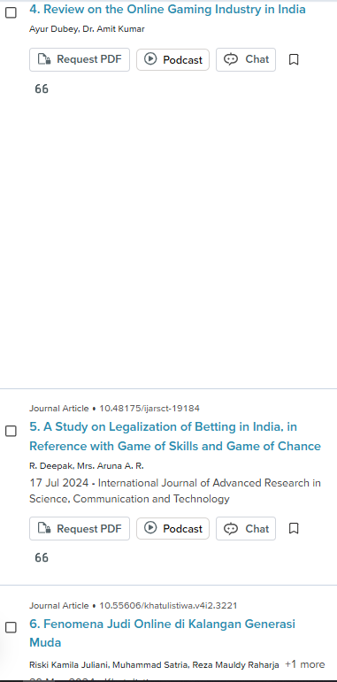
5. The Broader Implications: Ethical and Legal Gaps
- 5.1 Legal Ambiguity and Consumer Protection
  - Review the current legal landscape in India, specifically the distinction between games of skill and games of chance.
  - Discuss how this legal ambiguity allows apps to operate in a largely unregulated space (Indian Law Review, 2021).
  - Analyze the lack of robust consumer protection mechanisms and its consequences.
The legal landscape surrounding online betting in India is characterized by significant ambiguity, particularly in distinguishing between games of skill and games of chance. This lack of clarity allows various betting applications to operate in a largely unregulated environment, raising concerns about consumer protection and ethical implications.

Legal Ambiguity
- The Indian legal framework does not uniformly classify fantasy sports and online betting, leading to confusion over their legality. Courts have often ruled that games requiring skill, like fantasy sports, are permissible, while games of chance are not(Kamath et al., 2021)(Kumar, n.d.).
- This distinction enables platforms to market themselves as skill-based, thus circumventing stricter regulations applicable to gambling.

Consumer Protection Mechanisms
- The absence of robust consumer protection laws in the online betting sector leaves users vulnerable to exploitation. Many users, particularly from low-income backgrounds, are drawn into these platforms without adequate understanding of the risks involved(Kumar, n.d.).
- The lack of regulatory oversight can lead to issues such as addiction, financial loss, and inadequate recourse for consumers facing fraud or malpractice.
In contrast, some argue that the burgeoning fantasy sports market could stimulate economic growth and innovation, suggesting that a more nuanced regulatory approach might balance consumer protection with industry development(Kamath et al., 2021).

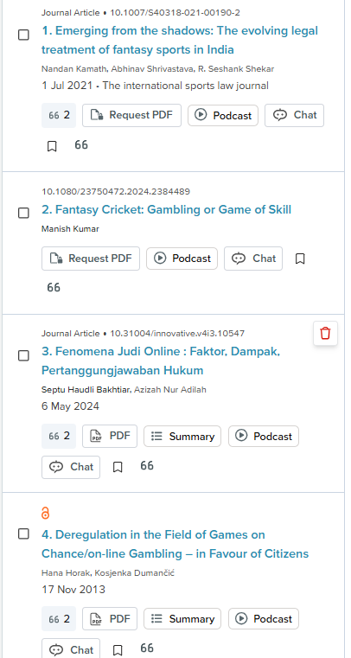

5.2 Ethical Concerns and Social Harm
- Discuss the ethical issues from a societal perspective.
- Synthesize research on the link between online betting and financial distress, mental health issues, and family conflict (Das, 2022).
- Conclude with a summary of the ethical responsibility of these platforms and the need for stronger regulatory oversight.

Online betting raises significant ethical concerns, particularly regarding its societal impact, including financial distress, mental health issues, and family conflict. The rapid growth of online gambling has been linked to increased rates of gambling disorders, which the WHO recognizes as a mental health condition. This situation necessitates a closer examination of the ethical responsibilities of online betting platforms and the need for enhanced regulatory oversight.

Financial Distress
- Online gambling can lead to severe financial problems for individuals, often resulting in debt and bankruptcy.
- Research indicates that excessive gambling is a primary contributor to financial distress, affecting not only the gamblers but also their families(Orford, 2019).

Mental Health Issues
- Studies show a strong correlation between online gambling and mental health disorders, including anxiety and depression(Dash & Howard, 2024).
- The addictive nature of online betting, exacerbated by digital marketing strategies, can lead to significant psychological distress(Weber & Silva, 2025).

Family Conflict
- The repercussions of gambling extend to family dynamics, often resulting in conflict and emotional strain among family members(Orford, 2019)(Tulloch et al., 2021).
- Family members of problem gamblers frequently experience stress and insecurity, highlighting the broader societal implications of gambling addiction(Orford, 2019).
In conclusion, while online betting platforms may assert their commitment to corporate social responsibility, the evidence suggests that they often prioritize profit over the well-being of their users. This reality underscores the urgent need for stronger regulatory frameworks to mitigate the social harms associated with online gambling and to hold these platforms accountable for their impact on individuals and families.
